** BURNTISLAND SAILING CLUB **

**Burntisland Regatta**

**Sailing Instructions**

**Sunday 9nd July 2017**

.*The members and management committee of Burntisland Sailing Club would like to wish you a warm welcome to its annual Regatta.*

**1. RULES**

1.1. The racing shall be governed by the current ISAF Racing Rules of Sailing as amended here below; subject to the International Regulations for the Prevention of Collision at Sea and the Forth Bylaws, general directions and current Notices to Mariners as published by Forth Ports Ltd. Also competitors must comply with the FYCA Safety Regulations appropriate to a Category 4R event. These documents are available for inspection on the websites of the referenced bodies.

1.2. Any boat sailing in the vicinity of the Regatta start shall be understood to have agreed to these conditions.

**2. CHANGES TO SAILING INSTRUCTIONS**

2.1. Any late changes to these Instructions will be advised by signalling flag L on the BSC flagpole prior to the first start and posting a written notice on the notice board in the Burntisland Sailing clubhouse.

**3. SCHEDULE OF RACES**

3.1. Races shall be run for the following handicap classes. The scheduled time of the class warning flags are as given below

|  |  |  |  |  |
| --- | --- | --- | --- | --- |
| **Class** | **Handicap** | **Flag** | **Warning** | **Start** |
| Novice Race | New to Racing | **3** | 13.25 | 13.30 |
| Slow Handicap | FYCA above 1066 | **2** | 13.40 | 13.45 |
| Fast Handicap | FYCA 1066 and below | **1** | 13.55 | 14.00 |

3.2. All yachts entering shall have FYCA PY handicaps, or must accept a trial handicap allocated by the Regatta Committee. Handicaps allocated by the FYCA will be used, see: http://fyca.org.uk/Data/Handicaps/2017Handicaps/index.php. Fast and Slow cruiser racers may fly any standard sailing rig.

**4. ENTRY**

4.1. Any owner or skipper wishing to participate must enter by signing a completed Entry Form (attached) and sending it to the Secretary Burntisland Sailing Club, Burntisland, Fife KY3 9DQ together with a fee of £5. Early entry will be appreciated by the committee. Entry forms will be accepted in the BSC clubhouse on Friday 7th July from 1800 till 2100.

4.2. The Regatta Committee may refuse entry to any yacht and shall give the reason.

**5. RESTRICTED SAIL OPTION.**

5.1. Yachts may request to use a restricted set of sails (RS - defined as no spinnaker or cruising chute, and no additional headsails than used to windward to be set at any time). This provision, made under FYCA guidance, is intended for yachts not equipped with a spinnaker, and for crews considered by the Race Committee to be 'less experienced', 'less capable' or 'short handed', the latter defined as less than 60% of the yacht's full crew. The RS provision will not be granted if, due to the course or weather conditions, no yachts are able to fly spinnakers.

5.2. To request the RS provision, a yacht must contact the Race Committee on VHF channel 77, on race day at least 15 minutes before its class warning signal is displayed. To be valid, the Race Committee must have confirmed their agreement before its class warning signal. It is at the absolute discretion of the Race Committee whether to accept an RS request or not on any particular day.

5.3. A yacht permitted to use the RS provision shall display a white pennant or flag on the backstay or other prominent position, from its class warning signal until it finishes.

5.4. A yacht permitted to use the RS provision shall receive a +4% handicap adjustment. All results, both in full and RS configuration, shall be considered in calculating overall series positions.

5.5. If fewer than 4 entries are received for any class the Race Officer may eliminate or combine classes or boats to ensure enjoyable racing.

**6. RACING AREAS AND COURSES**

6.1. The racing area will be in the Firth of Forth off Burntisland, as shown on Admiralty Charts 735 and 736.

6.2. Courses will be selected from the BSC 2017 course card attached.

6.3. Course Number selected from the BSC 2017 course card will be displayed on the BSC Bridge before the warning signal. (All marks to Port- red board Starboard- Green Board)

6.4. Shortened Course, The hoisting of flag ‘S’ accompanied by two sound signals, made when the leading yacht is approaching the last mark of a shortened course, will indicate that the race will finish by crossing the finishing line from the direction of that mark

**7. AREAS THAT ARE OBSTRUCTIONS**

7.1. **An isolated hazard the Kirkbush Rock is located approximately 250m east**

**of BSC Start/Finish line at 56̊ 03.248N 003̊ 13.633W**

7.2 Boats must keep a minimum of 100 m distant from the Braefoot Bay gas terminal and 0.5 mile from any moving tanker.

**8. MARKS**

List of Marks

|  |  |  |  |
| --- | --- | --- | --- |
| **B** | Blae (FPA Green No.7) | **P** | Pettycur (NOT IN USE) |
| **C** | Commons (orange BSC mark) | **S** | Sandend (orange BSC mark) |
| **D** | Braefoot M1 (green FPA mark) | **W** | Braefoot M4 (red FPA mark) |
| **F** | Degausing (orange BSC mark) | **X** | Outer distance (orange BSC mark) |
| **G** | West Gunnet (yellow & black FPA mark) | **Y** | Channel 11 (green FPA mark) |
| **L** | Lammerlaws (orange BSC mark) | **Z** | Channel 9 (green FPA mark) |
| **A** | Leith Approach | **Q** | Orange topped pillar buoy displaying flag ‘Q’ |

**(Bracketed letters on course card leave to opposite hand)**

8.3. Course Number will be displayed on the BSC Bridge before the warning signal. (All marks to Port- red board Starboard- Green Board)

**9. THE START**

9.1. The start and finish line will be between the flagpole on the bridge at Burntisland Sailing Club and the outer distance mark X

9.2. Races will be started according to Rule 26, i.e. a sequence flag and sound signals at 5-4-1-0 minutes before the start time, as set out below.

9.3. Any yacht not yet signalled to prepare must keep clear.

9.4 **Novice Race**

|  |  |  |  |  |
| --- | --- | --- | --- | --- |
| **Class** | **Time** | **Signal** | **Flag** | **Sound** |
| Novice Race | **13.30** | Warning signal | ↑ 3 raised | One Horn |
| Novice Race | **13.26** | Preparatory | ↑ P raised | One Horn |
| Novice Race | **13.29** | One minute | ↓ P lowered | One Horn |
| Novice Race | **13.30** | **Start** | ↓ 3 lowered | One long Horn |

9.5 **Slow Handicap Race**

|  |  |  |  |  |
| --- | --- | --- | --- | --- |
| **Class** | **Time** | **Signal** | **Flag** | **Sound** |
| Slow Handicap | **13.40** | Warning signal | ↑ 2 raised | One Horn |
| Slow Handicap | **13.41** | Preparatory | ↑ P raised | One Horn |
| Slow Handicap | **13.44** | One minute | ↓ P lowered | One Horn |
| Slow Handicap | **13.45** | **Start** | ↓ 2 lowered | One long Horn |

9.6 **Fast Handicap Race**

|  |  |  |  |  |
| --- | --- | --- | --- | --- |
| **Class** | **Time** | **Signal** | **Flag** | **Sound** |
| Novice Race | **13.55** | Warning signal | ↑ 2 raised | One Horn |
| Novice Race | **13.56** | Preparatory | ↑ P raised | One Horn |
| Novice Race | **13.59** | One minute | ↓ P lowered | One Horn |
| Novice Race | **14.00** | **Start** | ↓ 2 lowered | One long Horn |

**10. TIME LIMIT**

10.1 The time limit for all classes will be 17.00 hrs.

If one boat finishes within the limit the time limit will be extended by 30 minutes.

**11. RADIO COMMUNICATIONS**

11.1. Any boat which retires should inform the Race Officer, by any means, as soon as possible, such as by hail, or phone on 078106566195.

11.2 The race officer will maintain a listening watch on channel 16 and M1 for the

communication of safety information.

**12. PRIZES**

12.1. The traditional Burntisland Sailing Club trophies will be awarded (for one year’s home retention) to winning boats in each class and mementos may be awarded to worthy participants. Prize-giving will be held in Burntisland Sailing Club Clubhouse on day of the regatta after all racing has been completed. Participants and visitors are invited to join the Club sociably in the clubhouse for the prize giving.

**13. INSURANCE**

13.1. Each participating boat shall be insured with valid third-party liability insurance with a minimum cover of £2 million per event or the equivalent.

**14. Entry Fee**

14.1 Entry fee will be £5.00.

14.2 The Burntisland Sailing Club clubhouse will be open to all visitors all day during the Regatta, Tea, coffee and soft drinks will be available in the clubrooms.

14.3 Entries can be posted to Martin Birrell Secretary Burntisland Sailing Club,

Burntisland, Fife KY3 9DQ.

**Burntisland Sailing Club Course Card 2017**

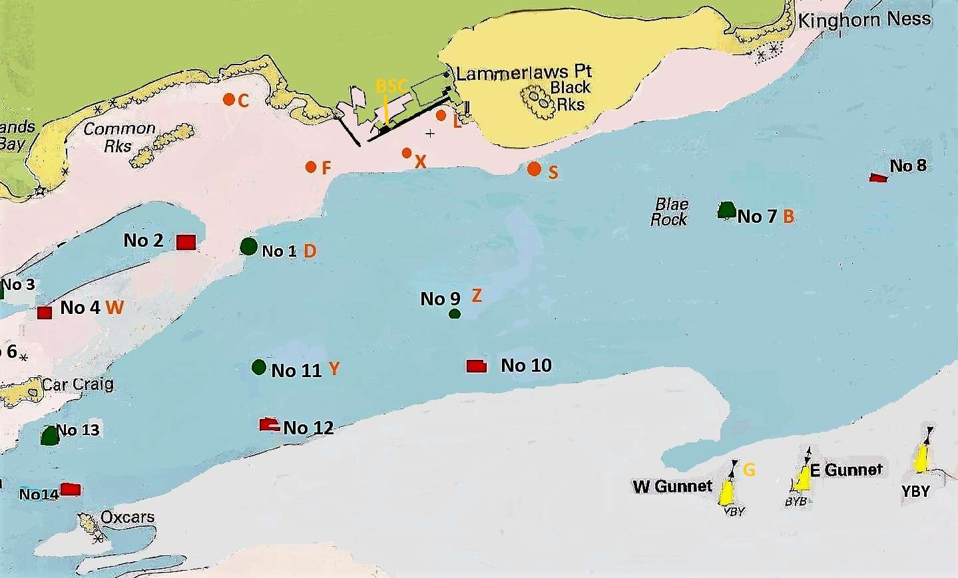

|  |  |  |  |
| --- | --- | --- | --- |
| **COURSE** | PORT | **STARBOARD** | DISTANCE |
| **1** | X F (X) L X | **X L (X) F X** | **1.7** |
| **2(*AV)** | **X F X S L X** | **X L S X F X** | **2.5** |
| **3(*AV)** | X D S L X | **X L S D X** | **2.7** |
| **4(*AV)** | **X C F X L X** | **X L X F C X** | **2.9** |
| **5** | **X D Z L X** | **X L Z D X** | **3.2** |
| **6** | X Y Z L X | **X L Z Y X** | **3.5** |
| **7** | **X F Y Z L X** | **X L Z Y F X** | **3.9** |
| **8** | **X C Y L X** | **X L Y C X** | **4.0** |
| **9** | X C D Y Z L X | **X L Z Y D C X** | **4.4** |
| **10** | X D Z B (S) X | **X (S) B Z D X** | **5.1** |
| **11** | **X W Z L X** | **X L Z W X** | **5.5** |
| **12** | **X C D Z B (S) X** | **X (S) B Z D C X** | **5.7** |
| **13** | **X C Y Z B (S) L X** | **X L (S) B Z Y C X** | **6.4** |
| **14** | **X W Y (Z) B (S) X** | X (S) B (Z) Y W X | **7.5** |
| **15** | **X W Y G B (S) X** | **X (S) B G Y W X** | **8.9** |
| **00** | Instructions from **OOD** | | |

**( )** Leave mark to opposite hand *AV – can be used as average Lap courses

List of Marks

|  |  |  |  |
| --- | --- | --- | --- |
| **B** | Blae Rock (FPA Green No.7) |  |  |
| **C** | Commons (orange BSC mark) | **S** | Sandend (orange BSC mark) |
| **D** | Braefoot M1 (green FPA mark) | **W** | Braefoot M4 (red FPA mark) |
| **F** | Degausing (orange BSC mark) | **X** | Outer distance (orange BSC mark) |
| **G** | West Gunnet (yellow & black FPA mark) | **Y** | Channel 11 (green FPA mark) |
| **L** | Lammerlaws (orange BSC mark) | **Z** | Channel 9 (green FPA mark) |

** BURNTISLAND SAILING CLUB **

**Burntisland Regatta**

**Sunday 9nd July 2017**

|  |  |
| --- | --- |
| **Owners Details** | **Yacht Details** |
| Owner’s Name in Full | Yacht Name |
| Yacht Club | Type/Class |
| Skipper’s Name | Sail Number |
| Address | FYCA Handicap |
|  | Hull Colour |
| Postcode | Class Entered |
| Telephone No | E-mail |
| Regatta entry fee | £5:00 |

Declaration

I wish to enter the Burntisland Sailing Club Regatta 2017. The information given above is correct. I agree to be bound by the Sailing Instructions issued for the event. Before Racing, I will affect the appropriate insurance cover. I understand that the organising club accepts no responsibility for the loss of life or injury to competitors or for the loss or damage to any vessel.

Signature of owner or owner’s representative……………………………………..

Date…………………………