Aquila
2023
Summer Cruise

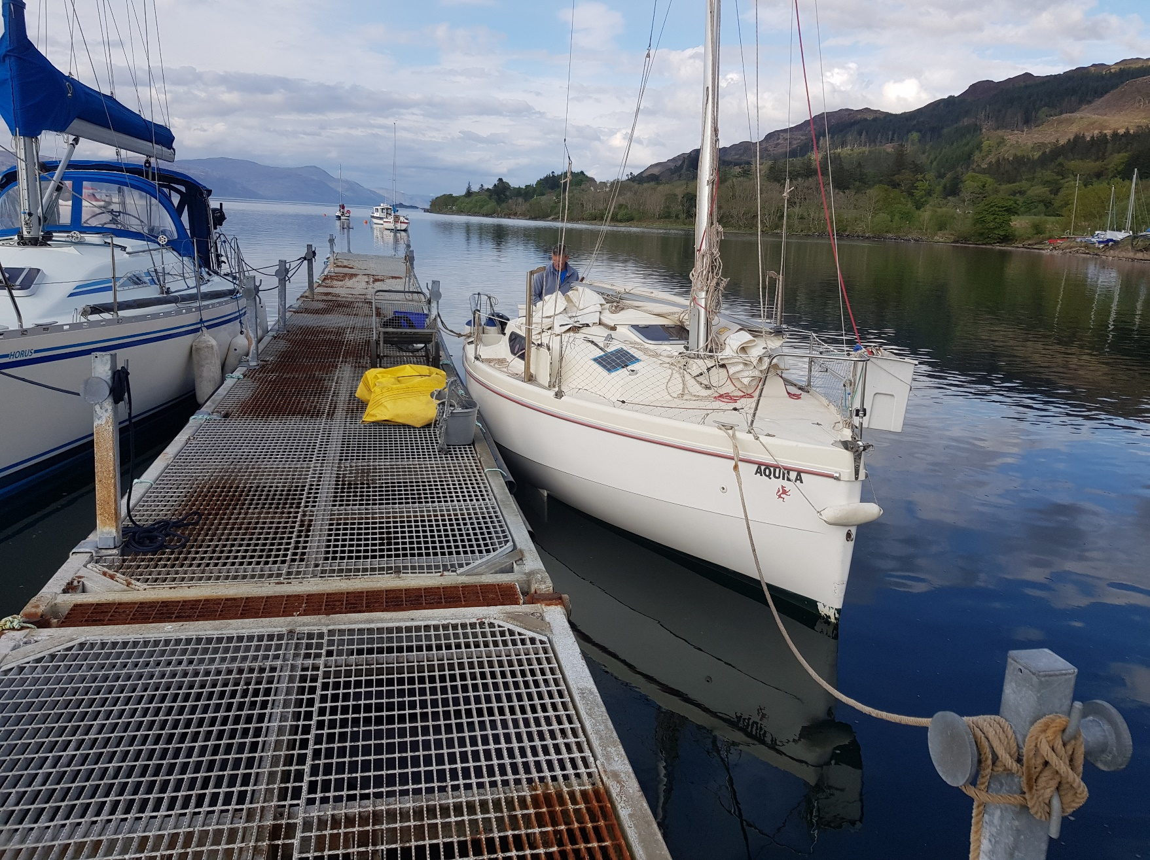
Setting up at Linnhe Marine

2

Itinerary
Planned Actual
Day Date From To
Saturday 6th May Home Linnhe Marine
Home Linnhe Marine
Sunday 7th May Linnhe Marine Tobermory
Linnhe Marine Tobermory
Monday 8th May Tobermory Loch Moidart
Tobermory Loch Moidart
Tuesday 9th May Loch Moidart Canna Harbour
Loch Moidart Canna Harbour
Wednesday 10th May Canna Harbour Arinagour, Coll
Canna Harbour Storm bound
Thursday 11th May Arinagour, Coll Tinker’s Hole, Mull
Canna Harbour Arinagour, Coll
Friday 12th May Tinker’s Hole, Mull Loch Tarbert, Jura
Arinagour, Coll Tinker’s Hole, Mull
Saturday 13th May Loch Tarbert, Jura Ardmore Islands, Islay
Tinker’s Hole, Mull Loch Tarbert, Jura
Sunday 14th May Ardmore Islands, Islay Port Ellen, Islay
Loch Tarbert, Jura Port Ellen, Islay
Monday 15th May Port Ellen, Islay Gigha
Port Ellen, Islay Loch Sween (Tayvallich)
Tuesday 16th May Gigha Loch Sween (Tayvallich)
Loch Sween (Tayvallich) Ardinamer, Loch Melfort
Wednesday 17th May Loch Sween (Tayvallich) Ardinamer, Loch Melfort
Ardinamer, Loch Melfort Loch Spelve, Mull
Thursday 18th May Ardinamer, Loch Melfort Port Ramsay, Lismore
Loch Spelve, Mull Port Ramsay, Lismore
Friday 19th May Port Ramsay Linnhe Marine
Port Ramsay Linnhe Marine
Saturday 20th May Linnhe Marine North Berwick
Linnhe Marine East Linton Garage

4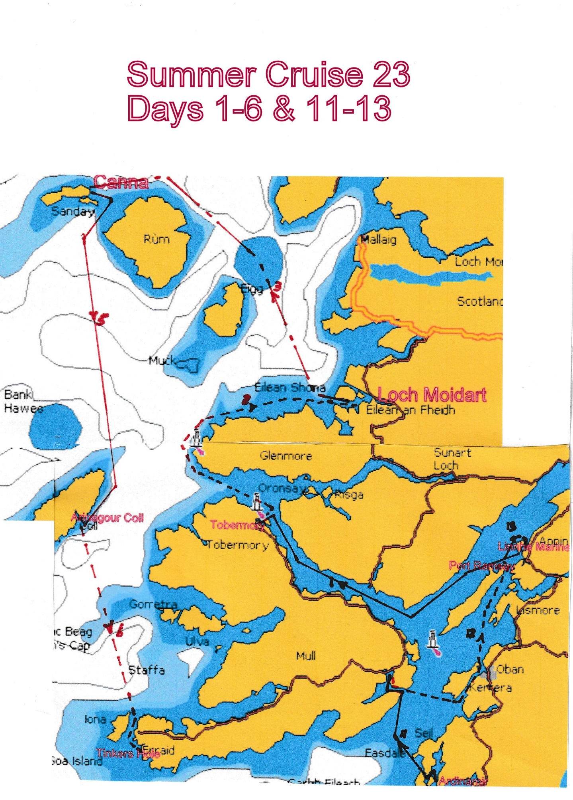
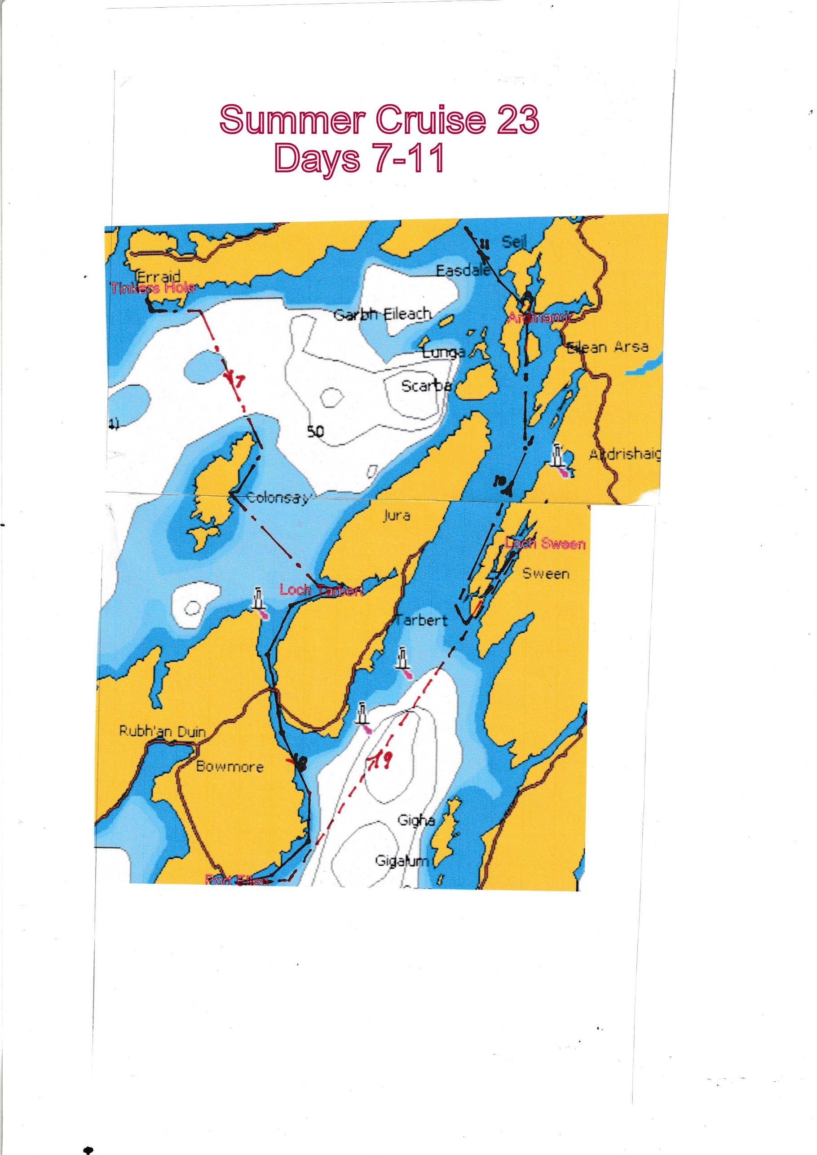
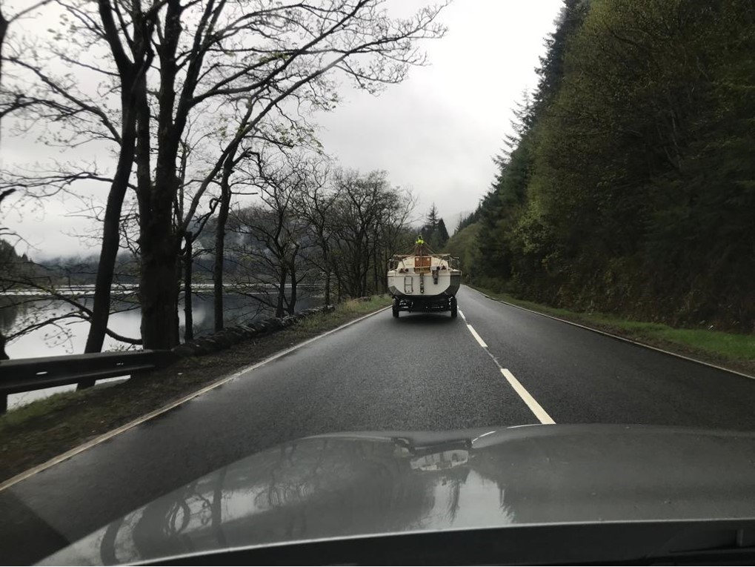
Being followed up the side of Loch Lubnaig

Forecast  Bright/Sunny | Distance Run  No boat mileage | Day 1 Home to Linnhe Marine (Saturday 6th May)  I left East Linton by 07.30 and hitched the trailer at Congalton by 07.50 which meant I arrived early at Longniddry to pick up Alastair. With roads quiet we made good time and as we drove up the side of Loch Lubnaig, we were overtaken by Neil McLeod and friends who were also heading west for a trip on the friend’s boat. (See Sunday’s log).  At 11.30, we stopped as usual at the Green Wellie for an early lunch. From there we chose the Glencoe road rather than our normal route along the Oban road and were surprised at the number of people walking the West Highland Way. We topped up with petrol at Ballachulish Petrol Station and arrived at Linnhe Marine at 13.15. The final access to the marina being from the large layby north of it, along a single track cycleway!  Manoeuvring from the cycleway into the yard was quite tricky but we got parked beside the slipway and with the yard owner helping on the winch, we had the mast up by 15.00 and the 2 of us launched at 15.45. While Alastair held the boat, I attached a rope to the trailer and soon had it pulled up the ramp and car and trailer parked where we had been shown.  Back at the boat, the engine started second pull and we motored over to moor on the inside of the pontoon hammerhead. It then took us another 3 hours to transfer all the gear from the car and start rigging. With a break at 19.00 for dinner, it was 21.00 before all the rigging and the Cuddie was in place and we relaxed below for a nightcap and bed.

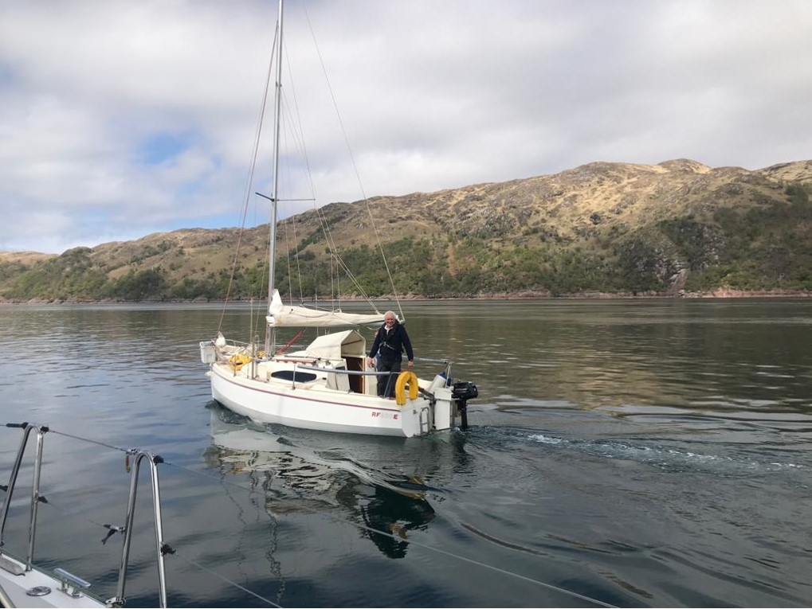
Overtaken by Neil McLeod & friends on their 43ft Arcona
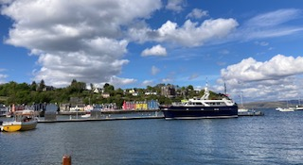
Tobermory

Forecast  S/SE 3/4 increasing 5/7 later,  Smooth/slight,  Slight/moderate,  Showers | Distance Run  Sail  1.5 hr  Motor Sail  1 hr  Engine  4.75 hr  25.5 nm | Day 2 Linnhe Marine to Tobermory (Sunday 7th May)  After a noisy night with both ourselves and the boat on the outside of the finger bumping against the pontoon fender, we woke to a flat calm and despite the ominous forecast there was still hardly any wind when we cast off at 09.30. Heading south towards the narrows between the mainland and Shona Island, as we switched the power on, the instruments promptly tripped leaving us with no depth, speed or wind information. Luckily the chart plotter kept working. Once clear of the Narrows I took the panel apart and after some deliberation, disconnected one of the wires linked to the instrument switch. This worked – no idea why – and power was restored to depth and speed but not wind.  Motoring down the Lynn of Morven we saw our first porpoise and a large fish farm boat was moored near the south end of the Lynn. Approaching the south end we were being gradually overtaken by another yacht and when it swung in close we realised that it was Neil McLeod and friends on their 43ft Arcona. After a few shouted greetings they soon pulled ahead and made their way up the Sound of Mull intending to reach Muck that evening. Once round into the Sound of Mull, we gradually hoisted the main, taking the chance to insert the forward reefing lines as it went up. With the jib also up and goosewinged, but still motor sailing, speed increased from 3.5k to 4.3/4.7k. By 14.00 we were able to switch the engine off and make 4.4k with the sails alone. Approaching Tobermory we telephoned ahead to arrange a berth and by 15.30 were inside Tobermory Bay. After started the engine and dropping the sails we selected one of the many vacant berths on the pontoons and were moored by 15.45. Going ashore to get fuel we found the garage was shut but were told at the marina office that it would be open early on Monday morning. After a stroll along the surprisingly quiet main street, we sampled the brew at the Mishnish local hostelry before heading back to cook our evening meal.

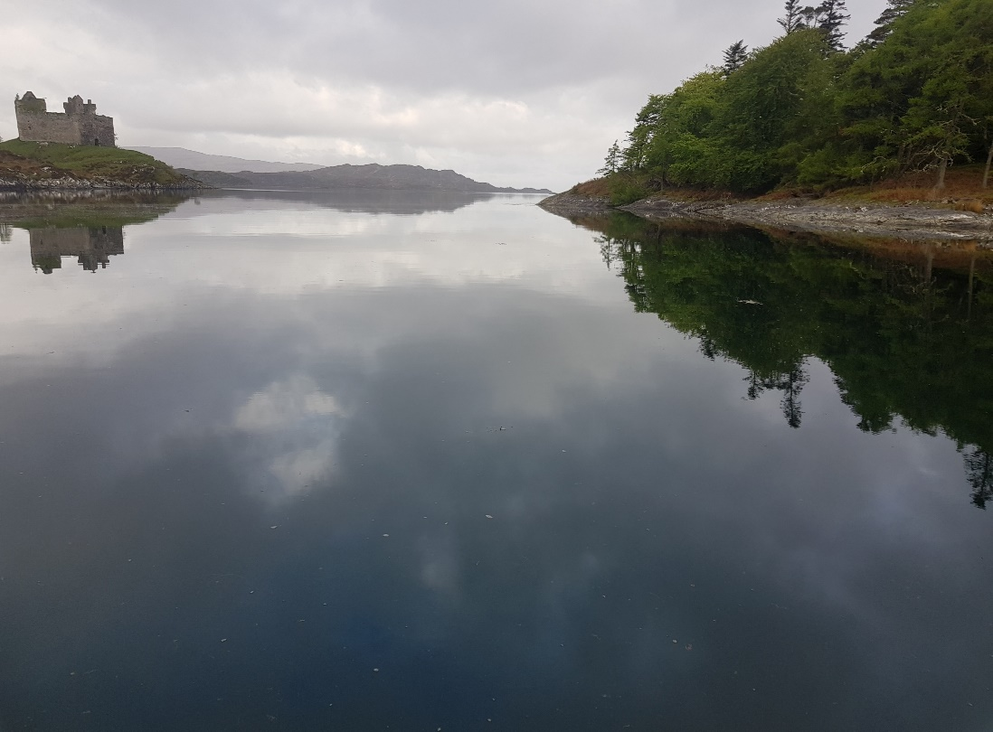
Castle Tiorum in Loch Moidart
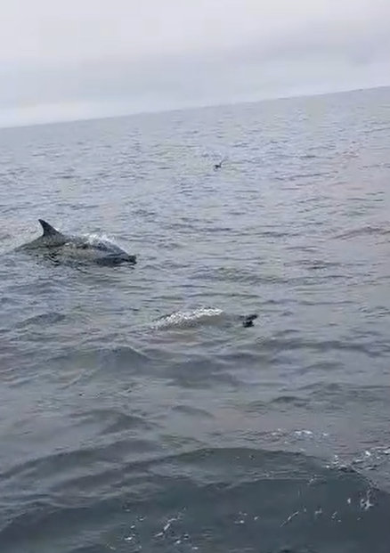
Dolphins playing round boat on way to Loch Moidart

Forecast  S 3-5 becoming variable mainly  SW 2-4,  Slight/moderate,  Smooth/slight in shelter,  Rain then thundery showers,  Fog patches moderate/good occ. Poor. | Distance Run  Sail  6 hr  Motor Sail  0.25 hr  Engine  1.5 hr  27.7 nm | Day 3 Tobermory to Loch Moidart (Monday 8th May)  Damp and overcast with poor visibility when we went ashore to shower, get fuel and shop for a new kettle, as the old one had sprung a leak. In late evening a large 3 masted sail training ship, registered in Jersey, and with an enormous bow sprit had moored on the outer hammerhead. By 10.15 we had slipped our moorings, cleared the marina, hoisted the main and jib and switched the engine off. To our surprise the wind indicator suddenly started to work and with 10-20k showing from the SW, we were making between 3.6 – 6k out of the bay. Setting a course for Ardnamurchan Point we were followed out of the bay and soon overtaken by a larger yacht as the Kilchoan Ferry appeared out of the murk ahead, heading for Tobermory. Approaching the Point, we could see what looked like the Northern Lighthouse service vessel stationery in the water to the south. In continuing poor visibility, with occasional rain, we rounded Ardnamurchan by 12.30 and set a course north for Loch Moidart. By 15.00 the rain had stopped, visibility had improved and the wind was down to 6-12k. The excitement of the afternoon came at 15.30 when a pod of dolphins surfaced alongside us and played around the boat for 10-15min enabling us to take a video of them. Approaching Rubha Aird Druimnich Point, the wind died and by 16.30 we had dropped the sails and motored on towards the entrance to Loch Moidart. After some hassle getting the chart plotter to locate us properly, we simply followed our previous recorded track in through the rocky entrance and up to the back of Riska Island. By 17.30, we had dropped anchor between the island and Castle Tiorum. The evening was brighter and dry but was still fairly chilly, so no chance of eating in the cockpit while watching a few late visitors looking at Castle Tiorum.

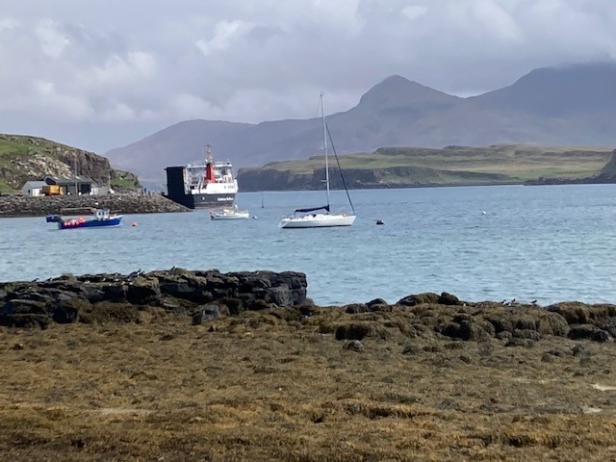
Looking to Ferry Berth Canna Harbour
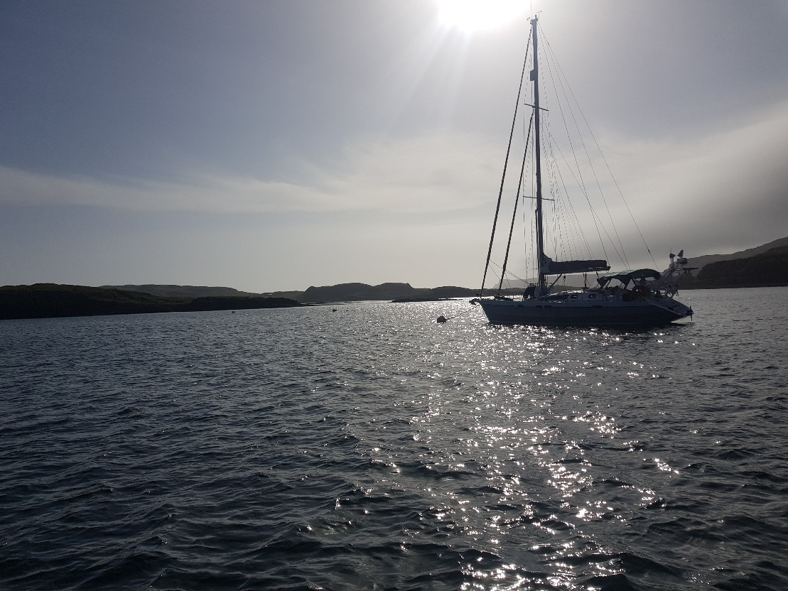
Looking west from mooring in Canna Harbour

Forecast  SW 2-4 backing  S 4/5,  Slight,  Mod to Rough,  Good occ Poor | Distance Run  Sail  1.75 hr  Motor Sail  1 hr  Engine Hrs  5.5 hr  33.6 nm | Day 4 Loch Moidart to Canna Harbour (Tuesday 9th May)  Up for the 07.10 Stornoway marine forecast, we were breakfasted and on our way by 08.50 having seen what might have been an otter just before we left. As it was close to high water we continued on to complete the circle round Riska Island, something we had not attempted before and we suspect would not be possible, even with our shallow draft, at low water. With our previous tracks clearly showing on the chart plotter, getting out of the rocky entrance was easy and once out by 09.40 we set a course of 333⁰ for Canna. Initially bright, but with an occasional shower of rain and little wind, we made 4.5kn on the engine. By 11.30 the forecast SW wind arrived and we got the sails up and the engine off. In 8-11kn of wind we made 3 -3.6kn for a short time until the wind started dropping. By 12.10, we switched the engine back on for 10minutes initially to assist, but as the wind swung more into the NW, we dropped the jib and motor sailed with just the main up. This only lasted until 12.45 when with the wind once again back up to 8 -12kn from the SW, we could make 3.5 – 5kn under sail. Although visibility was not great there were good views of Eigg as we progressed up its east side. Passing up the east coast of Rum, by 14.00 the wind dropped again, and we needed assistance from the engine for 15 minutes until the wind returned as we crossed the mouth of Loch Scresort. By 15.30, approaching the northern point of Rum, the wind had become more northerly and we were headed whichever tack we chose, so we dropped both sails and motored round the headland onto a new heading to take us to Canna. Assisted by the chart plotter, entrance to Canna Harbour was straight forward despite the complexities described in the Pilot Book! With only 3 other yachts in, we had a choice of visitor’s moorings and carefully selected one giving the shortest distance for rowing to shore. We were securely moored to our selected buoy by 17.20 in good time for a drink before dinner.

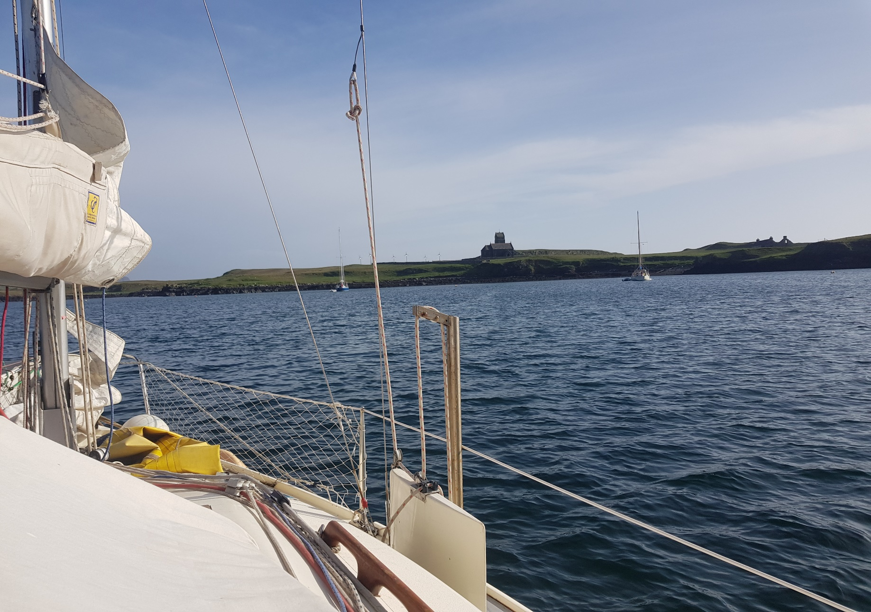
Looking South from mooring on Canna

Forecast  S/SW 4/5 increasing 6 in  the west reducing 4 later,  Moderate/rough,  Rain,  Visibility poor | Distance Run  Sail  0 hrs  Motor Sail  0 hrs  Engine Hrs  0 hrs  0 nm | Day 5 Stormbound in Canna Harbour (Wednesday 10th May)  We woke to a horrible wet misty day with a forecast of F6 with rough seas, and given that we would have had an extremely exposed passage, we decided to declare ourselves stormbound. We then spent most of the morning tidying inside the boat and transposing the rough working notes into the detailed log. Mid-morning, a couple of sea eagles flew over the anchorage before playing in the thermals over the hills to the north. Soon after that a high-speed rib arrived carrying 10 fully kitted up and very wet tourists who were landed at the slipway beside the RO RO berth. At 12.00 as the rain cleared and visibility improved, the Cal Mac ferry also arrived and disgorged more visitors. The rib and its 10 passengers left around 14.00 and by 14.30 the wind had eventually eased enough for us to inflate the dinghy and row ashore for a walk and to pay our mooring fees at the community shop. As we stopped at the café for a coffee, after we finished our walk, the ferry horn sounded and the few visitors about all re-embarked as the ferry left at 15.30. Against the still strong wind we then had a very hard row back to Aquila, congratulating ourselves that we had deliberately moored to the northern buoy nearest to the shore. With the dinghy deflated and secured on the foredeck again, it was time for an early evening libation before preparing the evening meal.  Throughout yesterday evening and today we watched workmen and machines moving between a contractor’s compound and a property further round the bay, past the café and shop. The only activity we could see was the tipping of excess spoil by dump trucks at the side of the access road. Notice boards beside the site compound explained that it was work commissioned by the National Trust to create new communal facilities at the ferry terminal and at the property where we had seen the spoil coming from.

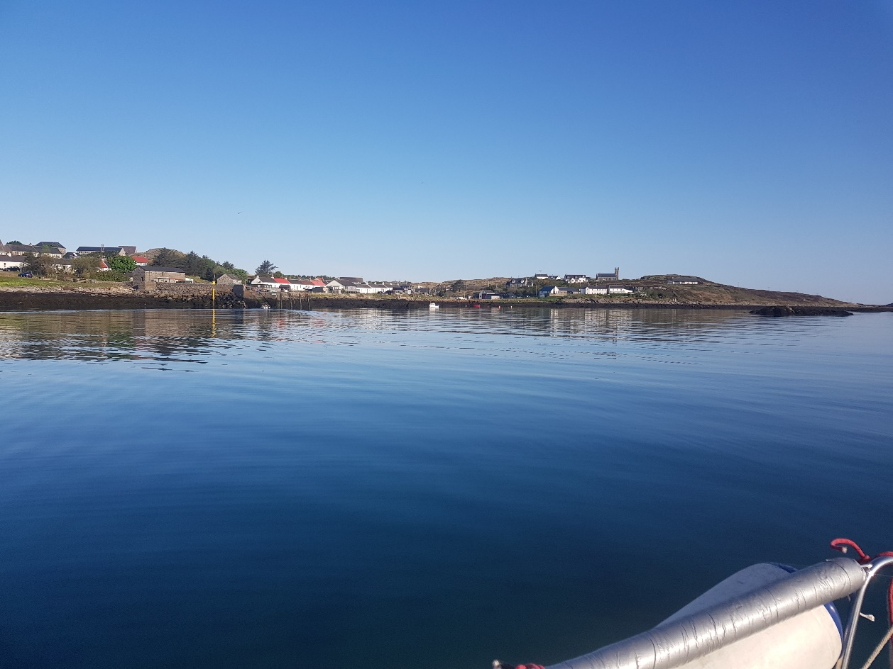
Arinagour looking north from our anchorage
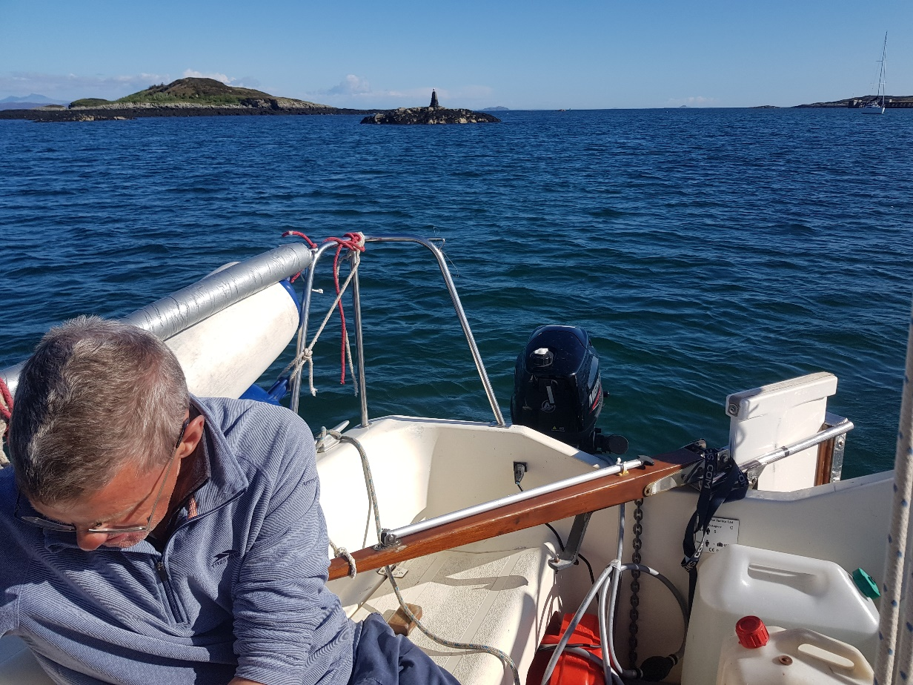
Looking south from our anchorage in Arinagour

Forecast  Variable becoming N/NE 2-4 possibly 5 in north,  Slight to Mod becoming smooth,  Moderate/Good | Distance Run  Sail  6.75 hr  Motor Sail  0 hr  Engine hrs  1.75 hr  32 nm | Day 6 Canna Harbour to Arinagour, Coll (Thursday 11th May)  It was a much better forecast at 7.30 and it was a bright, sunny, calm though chill day as we slipped from our mooring at 8.15 and had motored round into the Sound of Canna by 8.30. Although calm, there was still a noticeable swell in the Sound and this built steadily to 3-4m in height as we neared the western end. We were very glad we had not attempted this in Wednesday’s conditions. Once past the worst of it by 9.20, we turned head to wind, hoisted the sails and turn the engine off. It was still an uncomfortable swell as we tacked the boat downwind at 3.2 – 4.1kn in some 6 – 10kn of wind. By 12.00 when the wind started to drop, we put the spinnaker up and were still able to make 2.9 – 4.1kn. Approaching the east end of Coll by 14.30 we had to tack the boat and spinnaker to clear the exposed rocky point. Once clear south of the rocks by 15.00 we tacked back to sail along Coll’s southern shore. Now on a broad reach, we occasionally made 6kn in 12kn of wind but more generally made 4.2kn. As we made our way along this shoreline, we saw a Cal Mac ferry come out of the Sound of Mull and head for Barra. By 16.15 we dropped the sails as we turned inshore for Arinagour. There were 2 yachts moored on the visitor’s buoys and a French yacht anchored closer in. We crept inshore of the French yacht and dropped our anchor at 16.45 slightly north of the beacon as identified in the pilot book as the anchorage area. As we sat on deck in the evening sunshine having biscuits and cheese, 2 other yachts came in and picked up moorings. Later still a third yacht entered and after a thorough hunt around, anchored unnecessarily close to us. They then enquired whether we thought they were too close and we said yes, as Aquila swings a lot, so they lifted and moved to take one of the still vacant moorings.

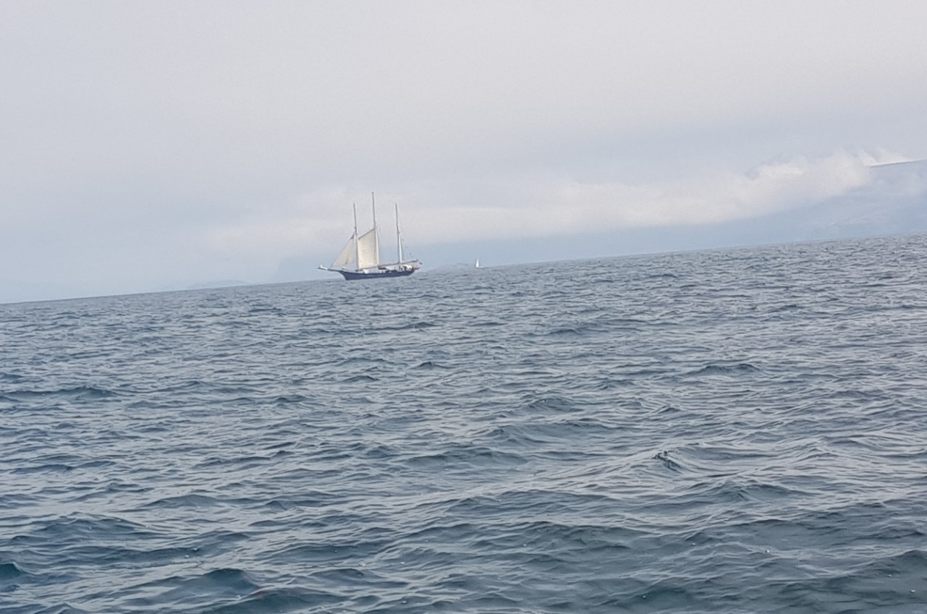
The Jersey registered 3 masted training vessel seen in Tobermory
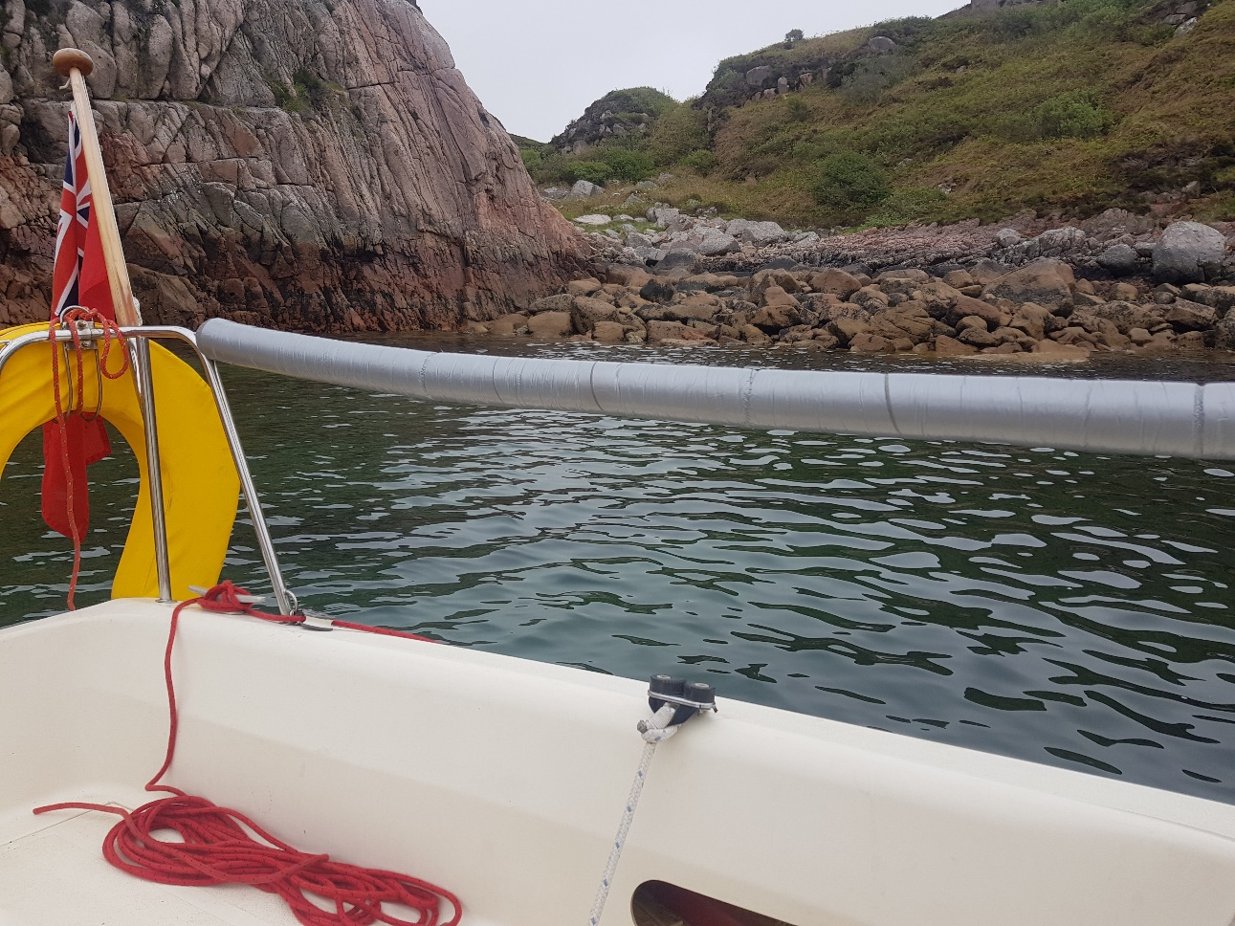
Tinker’s Hole

Forecast  Variable 2-4,  Slight/Moderate occ. Smooth,  Fog patches Moderate/good occ. Very poor, | Distance Run  Sail  2.25 hr  Motor Sail  0 hr  Engine Hrs  4 hr  24.5 nm | Day 7 Arinagour, Coll to Tinkers Hole (Friday 12th May)  It was another chill morning with a bright blue sky as we left the anchorage at 08.30 in a flat calm. Motoring past the yacht which had thankfully moved back to a mooring the previous night, we shouted our thanks. Out of the bay by 08.50 as we set a course of 180⁰ for the Treshnish Islands, in the distance we could see the Coll ferry coming out of the Sound of Mull heading for Arinagour where it docked around 09.55. Apart from a few puffins and other sea birds there was nothing else to see until approaching the Treshnish Islands we noticed some yachts moored in the anchorage on the north west side of Lunga, between it and Fladda. After passing between Lunga and the Dutchman’s Cap, a decent wind arrived and we got the sails up and engine off by 11.40. Initially making 3.7 – 4.9kn, we had to beat some 30⁰ below our desired course in 13 – 16kn of wind. Gradually as the wind shifted, we were able to come up and as we did so, a large cruise ship, the “Le Dumont-D’Urville” (430ft, 184 passengers) appeared to starboard, crossed astern of us, and continued on past Staffa towards the Sound of Mull. About 15min later at 12.15 the 3 masted training ship we had seen in Tobermory came out of the Sound of Iona and hoisted sails as it passed to the south of us. Approaching the Sound of Iona at 14.00, we dropped our sails and proceeded to motor through the northern passage. As we passed close to an anchored large French yacht we noticed that it had hugely angled twin dagger boards. Crossing to the southern shore, making use of the chart plotter, we entered the shallow channel starting at Eilean Ghomain and crept through to Tinker’s Hole. The anchorage was empty and we selected the prime spot in the north east corner, tucked up close to the rocks in 4.5m of water, and were all secure by 15.05.  Later in the evening as we were eating dinner, another yacht came in from the west, and anchored well clear of us.

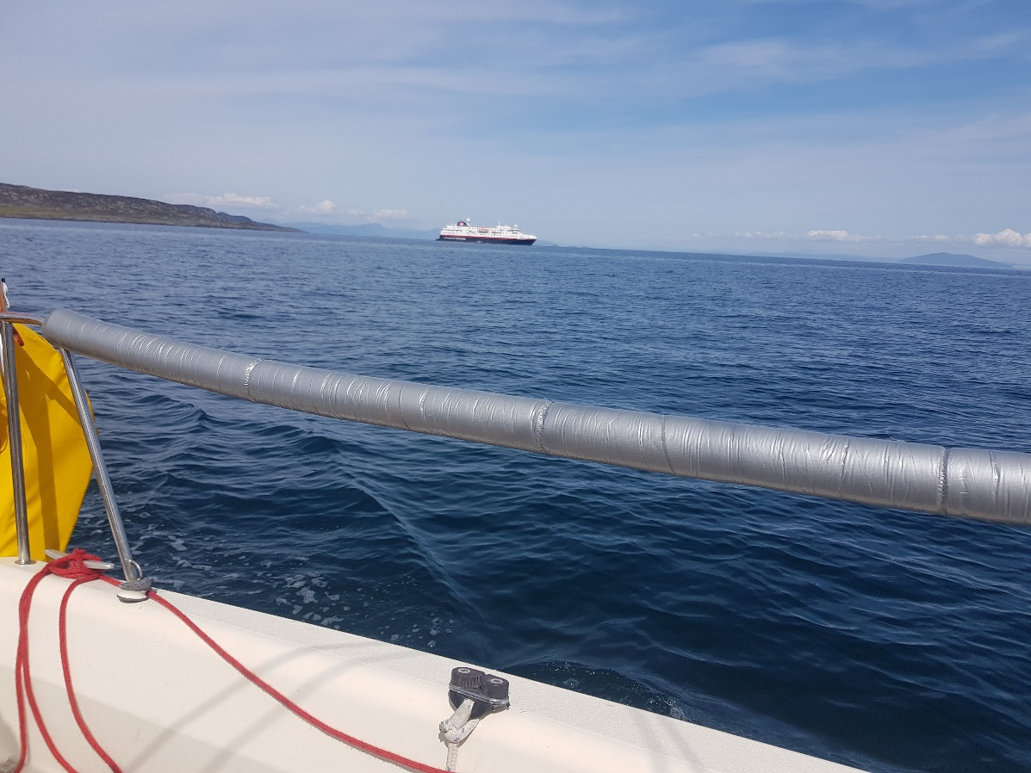
Cruise ship Spitzbergen from Tromso moored off Scalasay, Colonsay
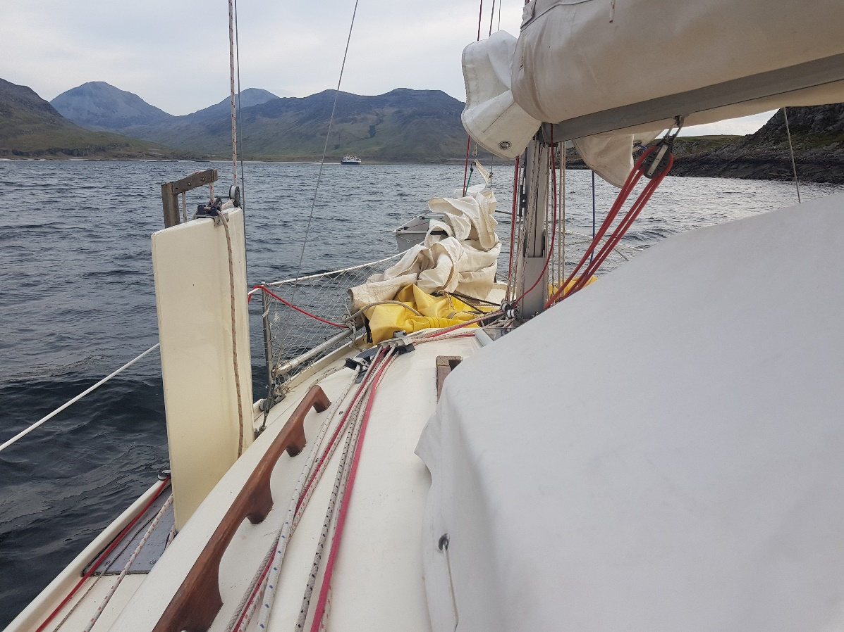
Smaller local cruise ship anchored in Loch Tarbert Jura

Forecast  Variable  SW 2 – 4 becoming SW 3 – 5 later,  Smooth/slight,  Fog rain later,  Moderate/good | Distance Run  Sail  0.5 hr  Motor Sail  0 hr  Engine Hrs  8 hr  32.2 nm | Day 8 Tinker’s Hole to Loch Tarbert, Jura (Saturday 13th May)  No Stornaway forecast at 7.10 but received Belfast at 8.10 and lifted anchor by 9.10. Motored out between the inshore rocks before heading to the Bogha nan Ramfhear North Cardinal, one of the Torran Rocks. Round the Cardinal Mark by 10.15 a course of 150⁰ was directly into the 14 – 20kn wind so we kept the engine on to make 4 – 4.2kn into the lumpy seas. At 11.30 we realised that the lazy jack ropes on the starboard side had pulled free, slid up the mast and then wrapped themselves round both the mast and the port lazy jacks! So even if we had wanted to, we couldn’t hoist the mainsail. Studying the pilot book, we thought there was a chance that there might be a suitable pier at Scalasaig on Colonsay, which would allow us to get high enough to retrieve the tangle of ropes. Rounding the northeast corner of Colonsay at 13.15, there was a cruise ship anchored off Scalasaig and the Colonsay Ferry was coming across from the Sound of Islay to enter the harbour. Luckily by the time we were turning to enter Scalasaig at 13.50, the ferry was leaving. By 14.10 we had moored on the north side of the pier and by using a taped extension on our longest boathook, we were able to reach the mast from the height of the jetty and soon retrieved the lazy jacks. Within 30 minutes we were on our way again, passing close to the moored Tromso registered Spitzbergen which was transferring passengers to and from shore in a fleet of small boats. As we continued across to Loch Tarbert on Jura, there was initially little wind until 15.40 when we raised the sails to make 2.5 – 4kn in 9 – 18kn of wind without the engine. This only lasted for 25 minutes before we had to revert to engine, drop the sails and head into Loch Tarbert. With 2 other yachts ahead of us, the preferred inner anchorage at Cuan Mor Bay would be full, so at 18.00 we selected an anchorage at Gleann Righ Beag on the north shore. Later a small local cruise boat anchored abeam of us in the middle of the loch

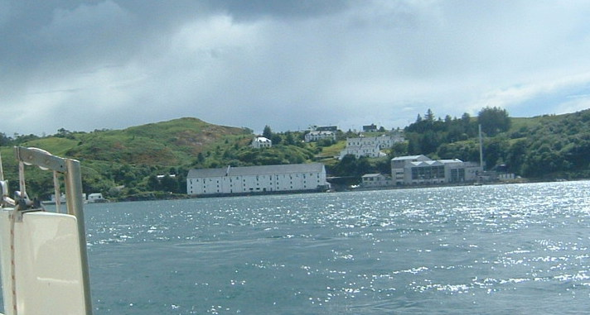
Caol Ila Distillery, Islay
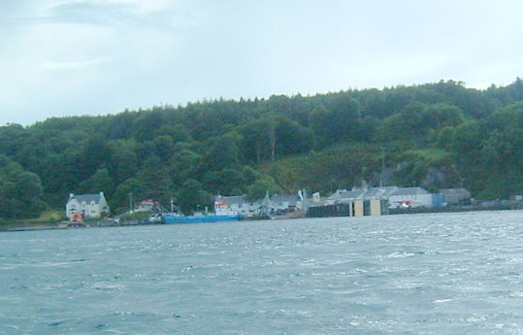
Port Askaig,
Islay

Forecast  Cyclonic becoming W/NW 3 – 5,  Moderate/rough,  Rain then showers,  Moderate/good occ poor at first | Distance Run  Sail  5.25 hr  Motor Sail  0.75 hr  Engine Hrs  2.75 hr  34.6 nm | Day 9 Loch Tarbert, Jura to Port Ellen, Islay (Sunday 14th May)  With no VHF reception in Loch Tarbert, we slept in until 7.30 and by then the local cruise ship had left and a large yacht was coming out from further up the loch. Timing our exit to suit the tidal stream in the Sound of Islay, it was 9.45 before we tried to raise the anchor. It took 15minutes to finally break a ball of weed free sufficiently to, with great difficulty, lift it far enough to be able to untangle it from the anchor. As we fought with this, a second yacht came passed us from further up the loch. Nearly out of the loch by 10.30, we hoisted the sails with 1 reef in and motor sailed until 11.00. Then with the engine off, we could set a course towards Bunnahabhain Distillery. By 12.15 the wind had risen to 20kn as we put the second reef in and were still making 4.5 – 6.5kn although the GPS showed 1.5kn less than this as we were still against the last of the flood tide. Level with Bunnahabhain by 12.25 and Ardnahoe Distillery by 12.36, we were opposite Caol Ila Distillery by 12.52. Once past Port Askaig the wind dropped and we shook out both reefs by 13.20. There was still 11 – 16kn of wind and we made 4.5 – 5.5kn on the log and 7.8kn on the GPS as the tide was now with us. Past McArthur’s Point lighthouse at 14.00, we had a good sail along the southern coast of Islay until opposite Lagavulin Distillery where the wind rose to 23 then 25kn and we put 2 reefs back in. Making little headway by 16.15 we put the engine on and dropped the sails and although showing 4.5 – 5kn on the log, we were only making 2.5 – 3kn over the ground. These final few miles were quite a slog before we passed inside the starboard entrance marker at 17.15. Tired and with a strong wind blowing in the marina we got blown off on our first approach to the pontoons. Then caught by the current, our second attempt was perhaps even worse, and we thumped the end of the finger berth quite hard. The final straw to this poor ending to the day was that there was no table available for dinner at the only hotel.

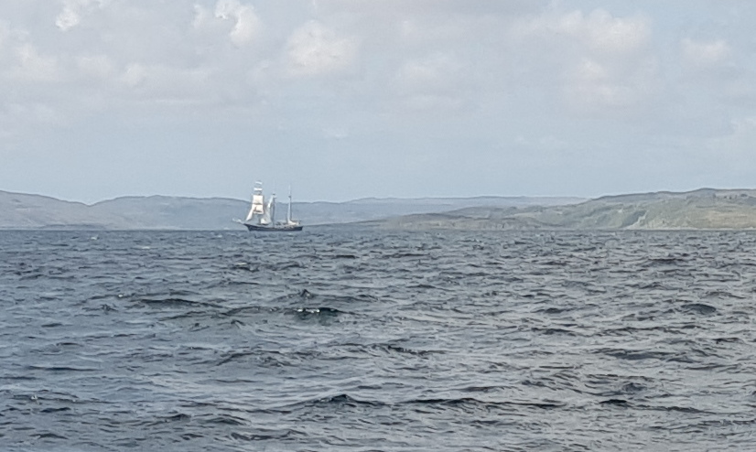
Yet again meeting the 3 masted training ship in the Sound of Jura
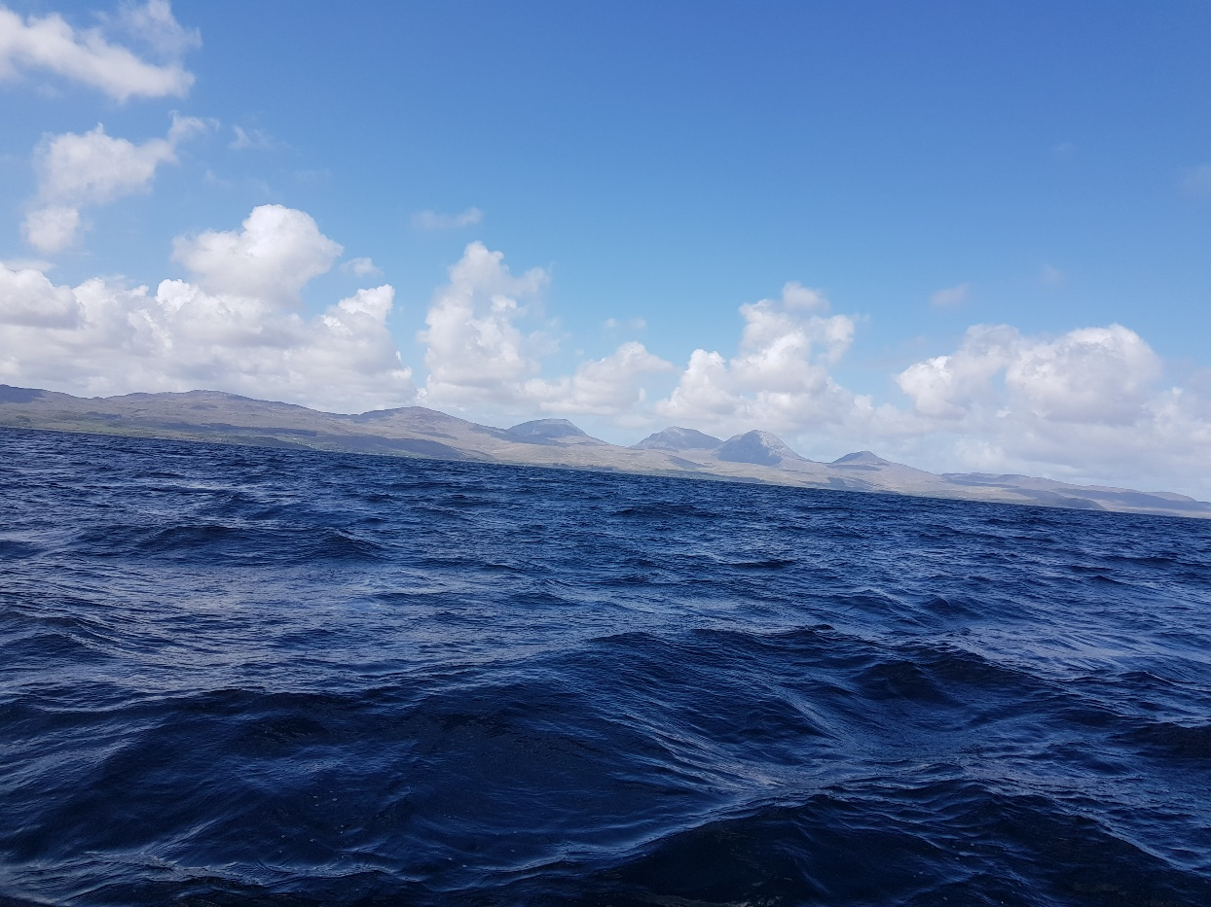
The Paps of Jura

Forecast  W/NW 3 – 5  Moderate/rough  Occ slight in the east,  Showers until later,  Good | Distance Run  Sail  7 hr  Motor Sail  0.5 hrs  Engine Hrs  1.5 hrs  41.1 nm | Day 10 Port Ellen, Isla to Loch Sween near Tayvallich (Monday 15th May)  We made use of the showers and toilet ashore and while Alastair went to the Co-op where there were few of the items we needed, I topped up water and fuel. After breakfast we discussed the forecast with a couple from another yacht who had intended going to Ireland, but given the forecast were heading for Gigha instead. Following them out, we cleared the starboard entrance buoy by 09.30 and hoisted the double reefed main in 10 – 15kn. Motor sailing until well clear of the offshore rocks, the outbound ferry passed us at 09.55. By 10.10 we were out beyond the rocks and able to stop the engine and set a course of 62⁰ for Craighouse on Jura. Hard on the 20kn wind, in poor visibility, and making 5.2kn, approaching Eilean a’Chuirn, we had an anxious few minutes trying to determine the intentions of an approaching large French yacht pinning us between them and the rocks! They eventually gave us room and passed to seaward of us. Re-assessing our course we realised that Craighouse was directly to windward of us but that Loch Sween, which was to have been the next day’s destination, could be reached on one tack, so we headed for there. Making 3.5 – 5.5kn in 11 – 20kn of wind, around 13.10, we saw the same 3 masted sail training ship in the distance, but this time she had square sails set from her foremast. Around 13.30 we shook out 1 reef which increased our speed to 6.7kn. By 15.30 aproaching the Garvellochs, a 45ft yacht came down from the north and entered Loch Sween just ahead of us. By 17.10, nearing Eilean Loaning at the head of the loch, we dropped the sails and motored through the narrow channel between the island and the east shore. There was no suitable anchorage as it was very deep right up to the shoreline. After a couple of abortive investigations of likely looking spots, we eventually found one near Achanamara and anchored at 17.50. Later we realised that there appeared to be a heron’s nest somewhere in the trees close inshore of us.

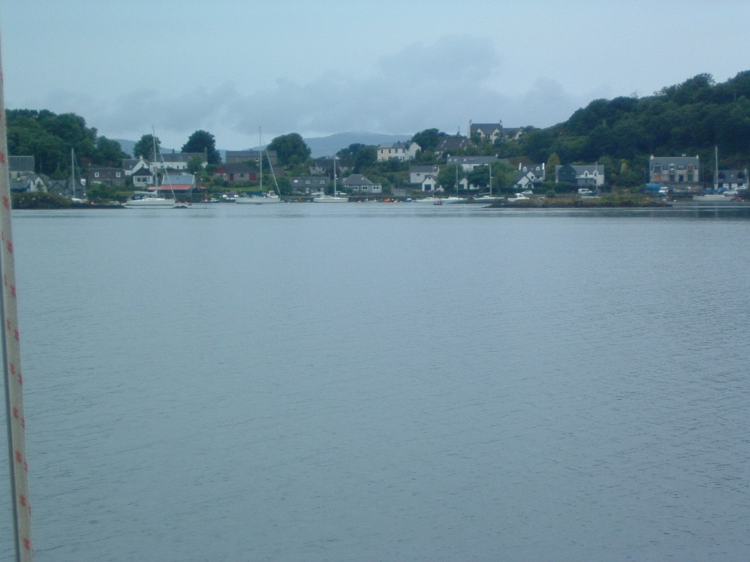
Looking into Tayvallich
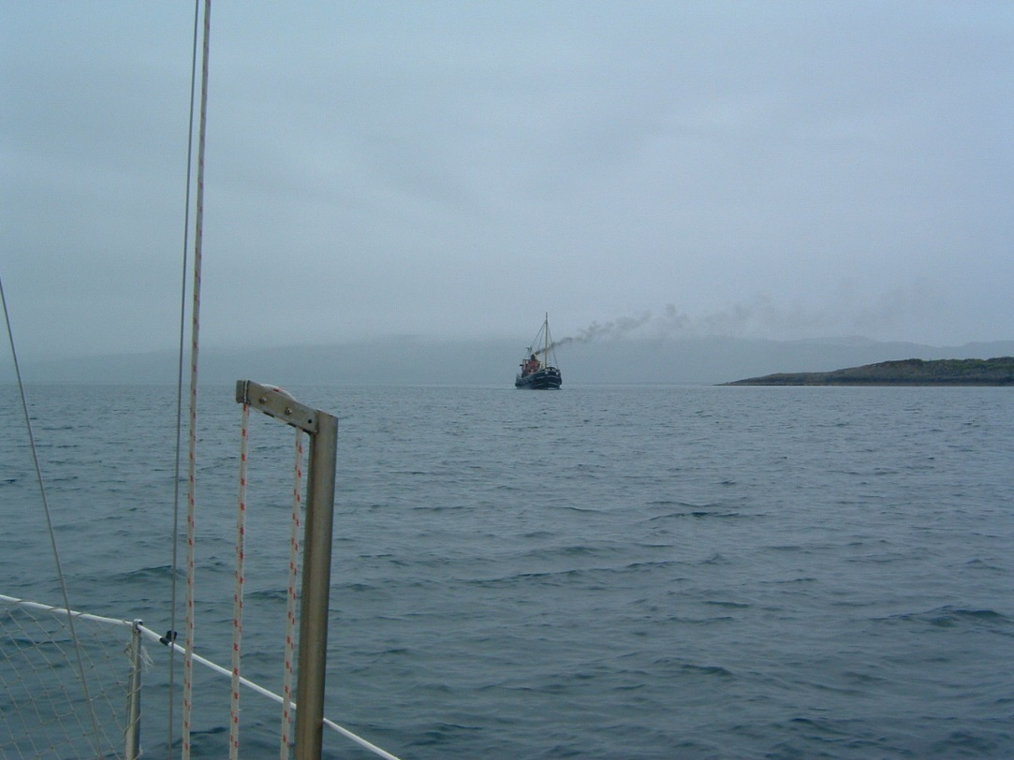
Approaching Dorus Mor on a previous occasion

Forecast  W/NW 3 -5 becoming variable 2-4 later,  Slight/moderate,  Showers,  Good | Distance Run  Sail  1hr  Motor Sail  2hrs  Engine hrs  4.5hrs  28.6 nm | Day 11 Loch Sween to Ardinamer (Loch Melfort) (Tuesday 16th May)  As we had to be at the mouth of Loch Sween by 09.05 to catch the start of the north going tide, we were on our way by 07.20 in very dull and overcast conditions. Discovered that the wind speed indicator had stopped working as it had come loose and moved round the mast. Another yacht out of Tayvallich headed down the loch just ahead of us but it continued south when we reached the Loch entrance at 08.45. A yacht which came down on the last of the ebb turned into Loch Sween as we headed out. The tide was turning as we rounded the headland at 09.20 in fairly rough conditions until we were well into the Sound of Jura. With an estimated wind of 15 – 25kn, we hoisted the main and motor sailed at 6kn. Back up level with Tayvallich by 10.10 and Crinan by 10.40, the weather was improving but it was still a cold slog. Approached Dorus Mor, a fishing boat hauling creels was in our way until we crossed her stern. By 11.20 a bare poled yacht came out from Ardfern and we followed her through the turbulence at Dorus. Once clear and settled on a course for Shuna we shook the 2 reefs out of the mainsail, hoisted the jib and got the engine off. Making 5.5kn we probably had about 18kn of wind. While heading for Shona, 2 very low flying jets screamed over us heading north. Past Shuna by 12.30, the wind increased and we dropped both sails and motored for the final 20 minutes towards Ardinamer. Approaching the narrow marked entrance, 3 kayakers paddled through and landed on the northern shore of the anchorage. By 13.00 we had followed them through between the perches, circled to select the best spot, and anchored. With some sunshine breaking through we were sitting having lunch in the cockpit when an equally low flying Hercules refuelling tanker flew overhead. After the kayakers left, we had the anchorage to ourselves until early evening when a large single handed deck saloon yacht swept in and anchored.

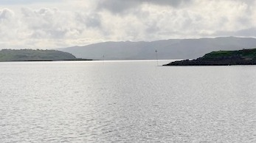
Looking out through the entrance perches at Ardinamer
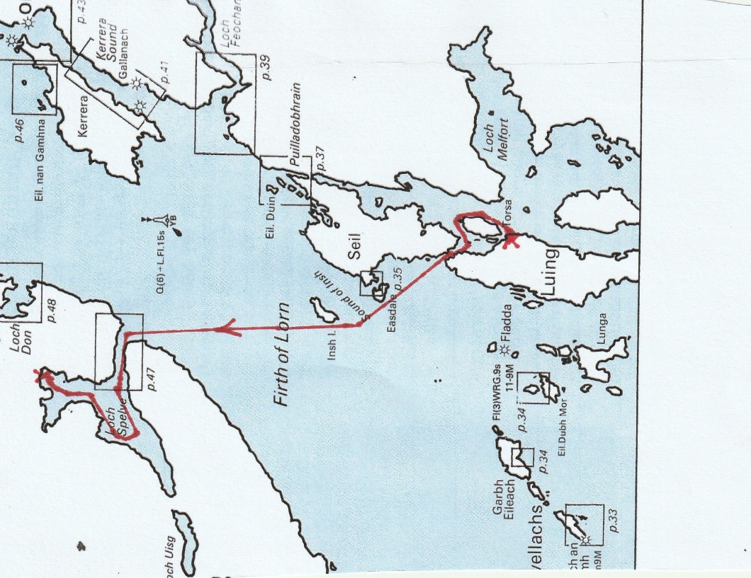
Course day 12

Forecast  W 2/3 backing SW 4/5 then variable 3 or less,  Smooth/slight,  Mainly fair,  Good | Distance Run  Sail  0 hrs  Motor Sail  0 hrs  Engine Hrs  3.75 hrs  14.3 nm | Day 12 Ardinamer to Loch Spelve (Wednesday 17th May)  We got up to blue sky and watery sunshine to receive the 07.10 Stornoway forecast and were out between the entrance perches by 0905. Rounding the headland into Cuan Sound there were a large group of kayakers breaking camp onshore. Crucially entering the extreme tidal gate at 09.25,exactly at slack water, we were past Cleit Rock and out the northern exit by 09.40. The wind indicator had moved again at the mast head, and was giving readings of only 3 – 4kn of wind. It was now dull overcast conditions as we continued to motor at 4kn on a course just to the south of Insh Island. Two yachts came down from the direction of Phuilladobhrain to the north, passed ahead of us and carried on down towards the Sound of Luing. Past Insh Island we set a direct course for the entrance to Loch Spelve. Reaching there by 11.30 we were followed through the entrance by another yacht which had come across from the direction of the Sound of Kerrera. We then explored up the southern leg of the loch as far as some fish farm markers where we turned and headed back to find an anchorage in our preferred area in the northeastern leg, beyond the mussel strings. Another yacht was already anchored in the prime spot, sheltered in behind the small island in this northeast corner. We found a slightly more exposed spot and at 12.45 dropped the anchor in 4.5m. Sitting having lunch in the cockpit we realised that we were swinging quite close to the shore so we laid a kedge anchor to try and reduce the extent of our swinging. While in place it successfully limited the extent of our swing, but it broke out occasionally and kept having to be reset. The weather remained dull and overcast but did stay dry. A few yachts came into the loch during the afternoon but they all went up to the more popular anchorage in the northwest corner.

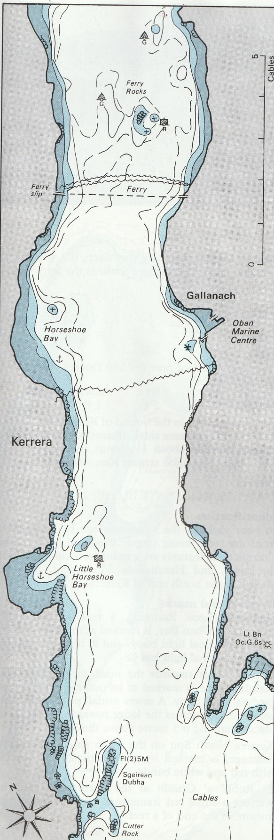
Sound of Kerrera

Forecast  S/SW 3/4 occasionally 5 in north veering W/SW 2-4,  Slight/moderate,  Occ rain later,  Rain/drizzle,  Moderate/good | Distance Run  Sail  4.25 hrs  Motor Sail  0 hrs  Engine Hrs  1.75 hrs  22.1 nm | Day 13 Loch Spelve to Port Ramsay, Lismore (Thursday 18th May)  It was still overcast and dull when we lifted the anchor at 08.50. Motoring out we passed fish farm workers on a specialist work boat, mechanically stripping mussels from the strings on which they grow. As we approached them a golden eagle swooped low over the boat to then disappear over the surrounding hills. At the exit, we estimated the current at 3kn as we were swept out and into rough water where the current hit open sea. Clear by 09.30, with sails up and engine off, we made 3.5 – 4kn in 8 – 10kn of wind on a course of 119⁰ towards the southern end of the Sound of Kerrera. By 10.15 with Dubh Squir well south of us, we reefed in 16 – 17kn of wind. Distracted while doing this, we caught a creel line, but managed to free ourselves by simply lifting the port dagger board. Trying to then tighten the reef in further, we sheared the fixing of the reefing block at the foot of the mast. By 10.45 in slightly calmer conditions in the Sound of Kerrera, we managed to replace the fitting and fully tension the reef. Until 11.30 we then had a pleasant sail up the Sound. Then as we approached Oban and the moored cruise ship Spitzbergen (which we had seen at Colonsay), a Calmac ferry came in through the northern entrance, another one headed out, and as we followed, a large yacht under power surged up to leeward of us, crossed our stern and passed us to windward. Once in the Sound of Lynn, we shook the reef out as a posh looking motor yacht/cruise ship passed heading for Oban. Up the Sound of Lynn the wind was variable 4 – 10kn and when it dropped further at 13.15 we hoisted the spinnaker. We were late dropping all sails as we approached the channel marking perches at the Lismore Narrows and it was all very hectic. At the next port marker perch, with a submerged rock close to starboard, we waited to allow a quarry ferry through before us. Another perch then guiding us into Port Ramsay anchorage where it took 3 attempts in two areas before the anchor gripped and we felt secure.

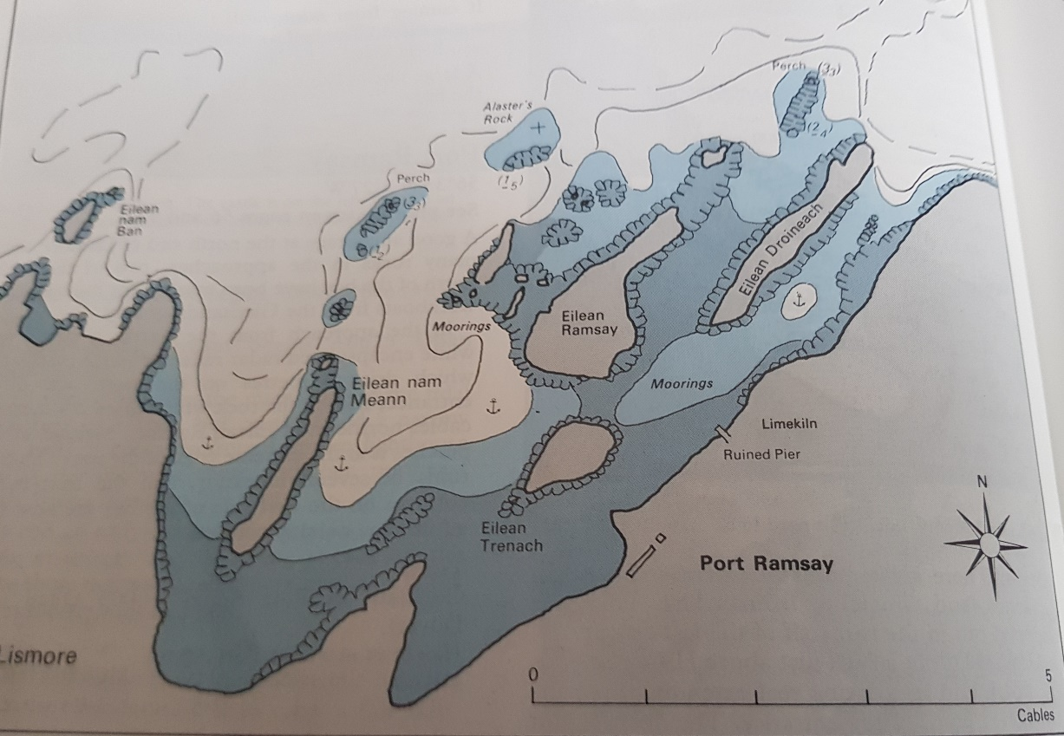
Port Ramsay (anchored near Eilean Ramsay after trying near Eilean Nam Meann)
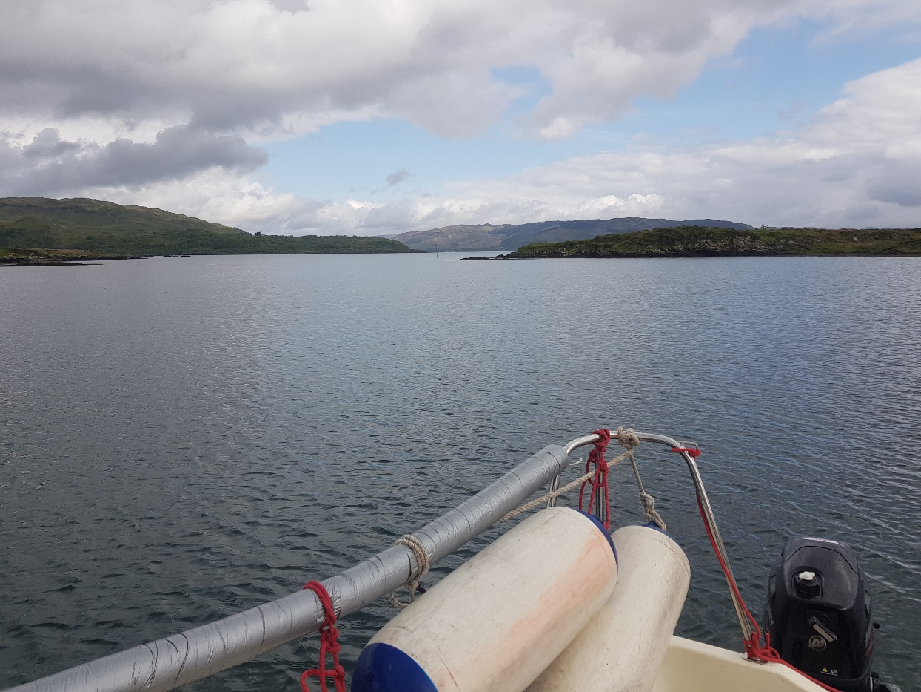
Looking back at perch marking entrance to Port Ramsay

Forecast  W/SW 2-4 becoming variable 3 or less,  Moderate/rough,  Showers | Distance Run  Sail  0 hrs  Motor Sail  0 hrs  Engine Hrs  1.75 hrs  5.3 nm | Day 14 Port Ramsay, Lismore to Linnhe Marine (Friday 19th May)  With no need to rush, and a dull windless day, it was 08.45 before we lifted the anchor and motored out the entrance channel. Hoping for some wind for a final sail, we headed for the north end of Shuna but although it brightened, no wind came. A fish farm service boat was moored to the cages at the north end of Shuna and we slipped between it and the shore to motor round to Linnhe Marine’s pontoons where we tied up at 10.30 having done only 5.3nm. As we approached the pontoons, the yacht which had been moored near us in Port Ramsay came in the southern entrance and tied up on the outside of the hammerhead. After a relaxed morning chatting to the marina owners and a cooked lunch, we made a start to stripping the boat and transferring gear to the car for transit. The other yacht was also decommissioning but they had problems up the mast and one of them spent most of the afternoon hanging in a bosuns chair at various positions up the mast. The afternoon was sunny and warm and a slight breeze developed. Finished by 16.30, we had plenty of time to shower, clean up, and have a drink before facing the 20 minute walk to the Old Ship Inn for dinner. Our table at the Old Ship was beside that of the two owners from the yacht with the mast problems who were from the North of England but kept their boat at Linnhe Marine. Having finished their meal and facing a long drive home the next day, they left soon after we arrived.

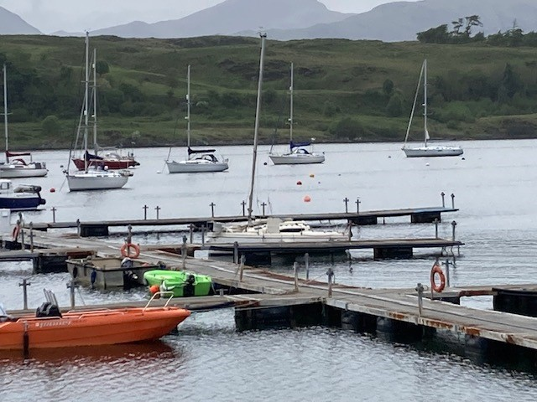
Moored at end of cruise
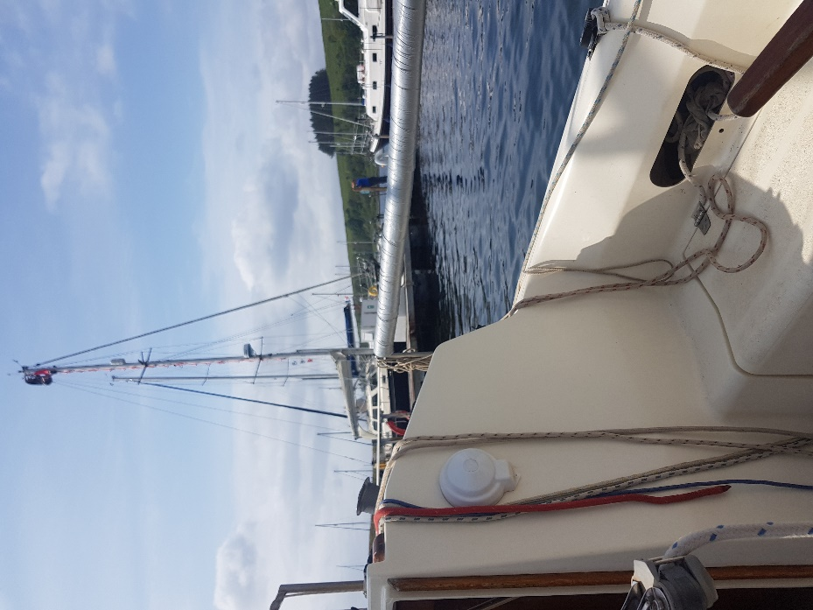
Man up mast

Forecast | Distance Run  Total Sailing  36.25 hrs  Sailing % of trip  46.6 %  Total spinnaker  4.5 hrs  Total Motor Sail  5.5 hrs  Engine Hrs  41.5 hrs  Fuel used  30 -37l  ie 0.7 -0.9l per hr | Day 15 Linnhe Marine to East Linton (Saturday 20th May)  It was an ideal bright flat calm day to get the boat onto the trailer but we had to wait until there was sufficient water on the slip. We then reversed the trailer down and lowered it the final few meters into the water on a rope. By 08.45, with the easiest recovery ever, the boat was on the trailer and pulled to the top of the ramp. It still took until 11.30 to drop the mast and prepare for towing. Pulling out of the yard we met a car trying to come in and it had to reverse a considerable distance back before there was a wide enough section for us to pass. Returning via Connel Bridge it was a quiet pleasant journey to the Green Wellie at Tyndrum where we stopped for lunch at 12.45. On through Calendar and down the M9 we were progressing well, until approaching Sherrifhall Roundabout we felt the trailer juddering. Luckily just short of a layby we pulled in to find the offside trailer tyre had disintegrated. Well prepared with a spare and a 2 ton hydraulic jack, we soon had the wheel replaced and gingerly set off again. Then at 17.30,on the section of dual carriageway just before Longniddry, Alastair spotted in the mirror that the nearside tyre was also starting to fail. Pulling into the bus stop layby, we found that tyre had also disintegrated. We contacted the AA who initially were not sure what they could do, but they did arrange for a patrol to come. It arrived about 1hr 20m later and was equipped with a selection of special hubs which fitted to the trailer hub. One of their various space saver wheels then fitted to their hub. Once fitted and inflated sufficiently we were able to proceed at up to 40mph with the AA van following us. I dropped Alastair off in Longniddry and slowly drove to the East Linton garage where the AA man retrieved his wheel and hub. He replaced the disintegrated tyre and wheel to keep the trailer level until the garage could replace the tyres. So instead of the boat being left at North Berwick by 16.30 as had seemed likely, it was 19.30 before it was abandoned on the garage forecourt in East Linton.

